**State Machine Diagram Description:**

**Shopping Cart**

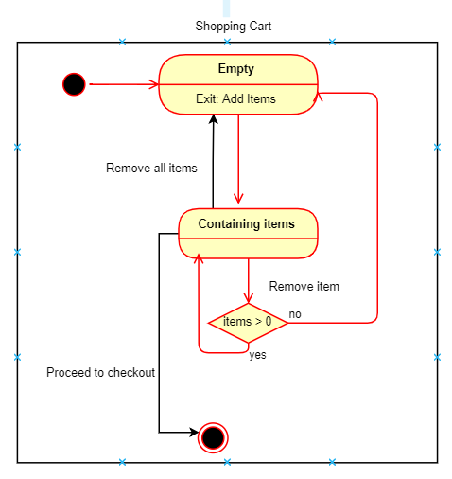 **w**

|  |  |
| --- | --- |
| **Status** | **Description** |
| Empty | The Shopping Cart is now empty. Exits to Add Items on adding items . |
| Containing items | The Shopping Cart is now filled. The customer can now add, remove (if items>0) or Proceed to checkout. |

**Proceed to Checkout**

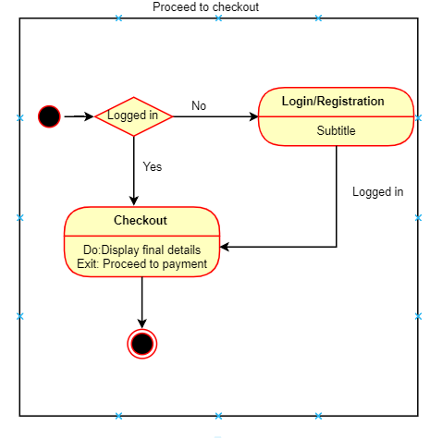

|  |  |
| --- | --- |
| **Status** | **Description** |
| Logged in (conditional status) | If the customer has already logged in, it goes to Checkout status and if the customer has not logged in or registered, it goes to the Login/Registration status. |
| Login/Registration | Exits to the Login/Registration |
| Checkout | Displays the final details and exits to Proceed to Method . |

**Login/Registration**

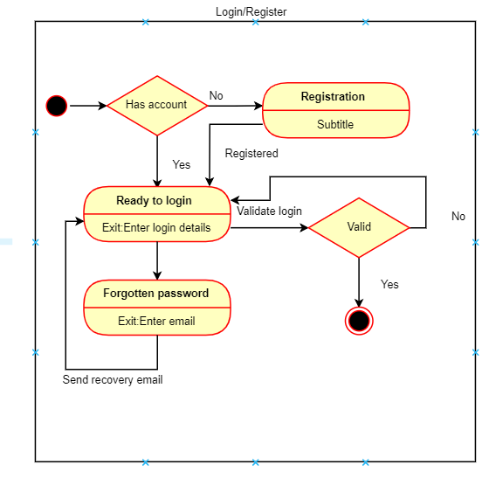

|  |  |
| --- | --- |
| **Status** | **Description** |
| Has Account (conditional status) | If the customer already has an account, it exits to Ready to Login status and if the customer does not have a account, customer is suppose to create an account and thus exits to Registration. |
| Registration | Asks the customer to create an account and exits to Ready to login status. |
| Ready to Login | Asks the customer to enter the login credentials and then validates it. If the customer has forgotten his/her password it exits to Forgotten Password. |
| Forgotten Password | Sends a recovery email with the new password to the customer and exits to the Ready to Login status to allow the customer to login again |

**Scan and display Items**

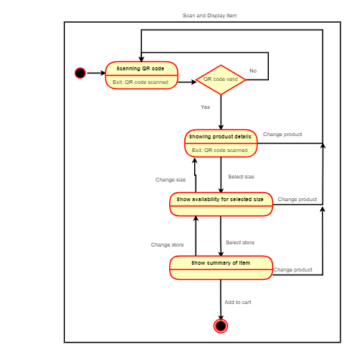

|  |  |
| --- | --- |
| **Status** | **Description** |
| Scanning QR code | The customer scans the QR code of the item, and the system tries to validate it, if it’s incorrect the customer is supposed to scan the item again and if the item gets detected it goes to the Showing Product Details status. |
| Showing Product details | The system displays the product details and the customer gets to choose the preferred size of the apparel and the system goes to the Show availability status. The customer also has the authority to change the item and the system goes back to the Scanning QR code status. |
| Show availability for the selected size | The system checks for the availability of the preferred size of the apparel in the nearby stores and displays it to customer and then the customer gets to choose the store. The system then jumps to Show item summary status and if the customer does not find the preferred product in his/her size, they can still change the product. |
| Show Item summary | The system displays the product detail and the customer can still change the product. If the customer wants to proceed, the system will exit to Add to Cart. |